**DAY 11 – ASSIGNMENT**

**Create a New Table Using Existing Table with Table Functions**

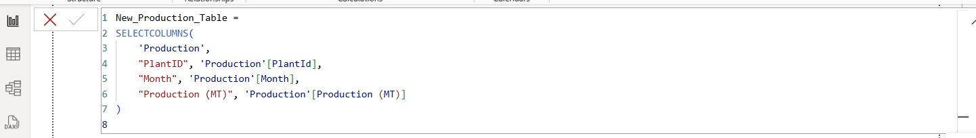

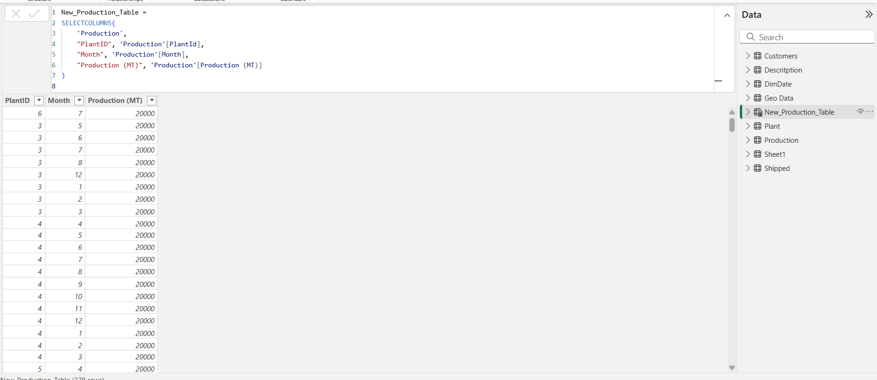

**Create a Measure to Calculate the Sum of Target MT**



**Create a Column 'Difference' (Target – Production) in Production Table**

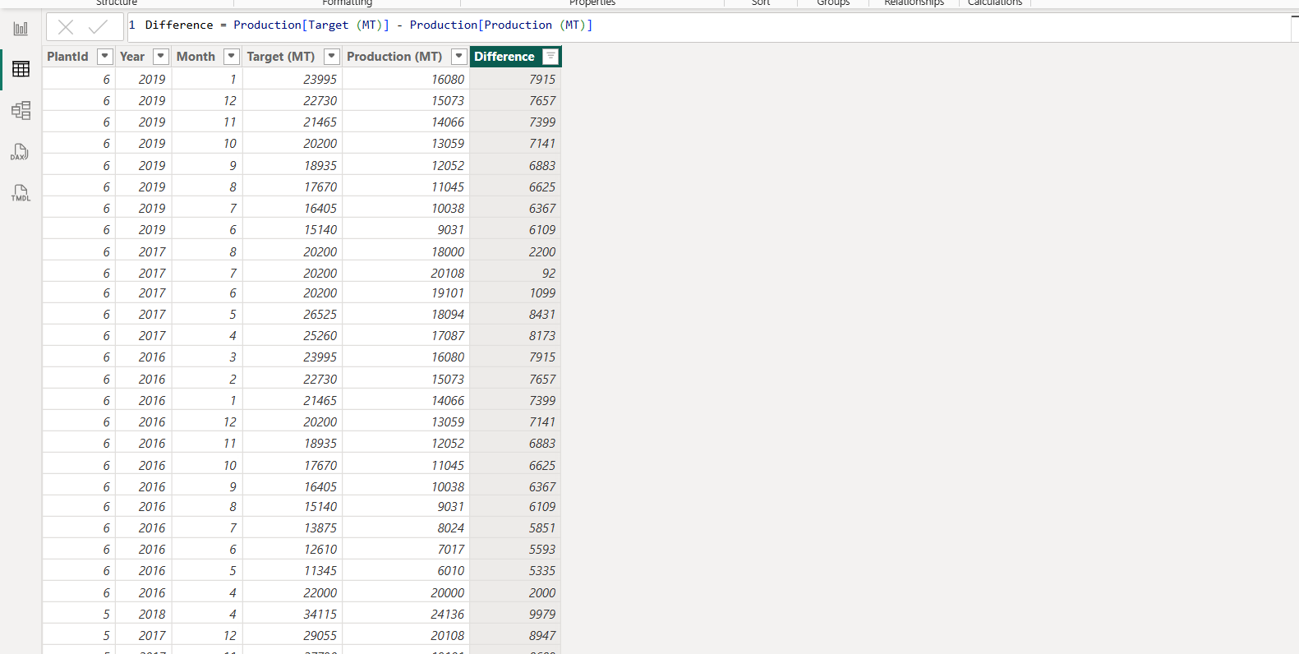

**Create a Calculated Column to Join First Name and Last Name**

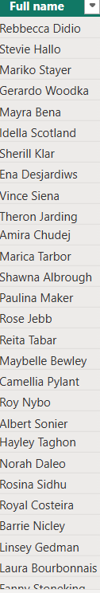

**Create a New Measure to Calculate Sum of Production using VAR Function**



**Create a Quick Measure to Find YTD & MTD of Production**

**➤ for YTD (Year-to-Date):**

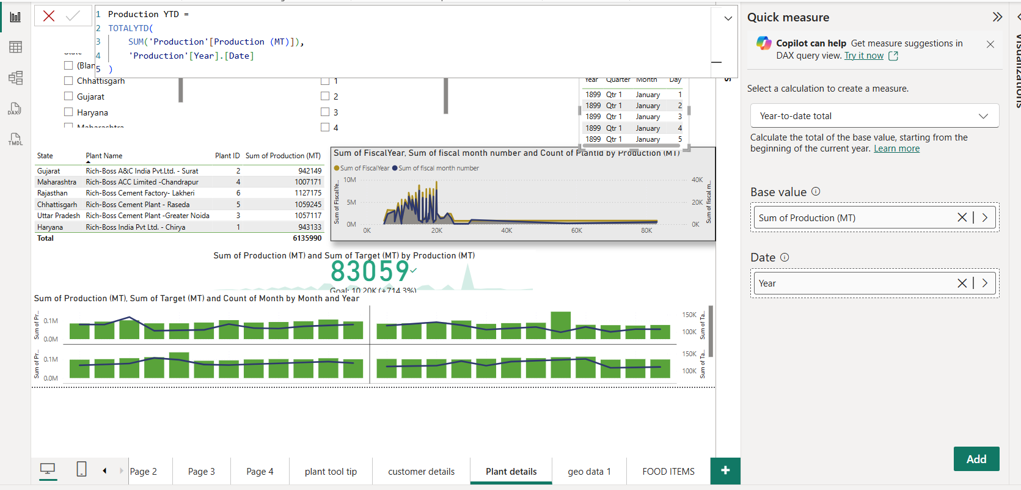

**➤ for MTD (Month-to-Date):**

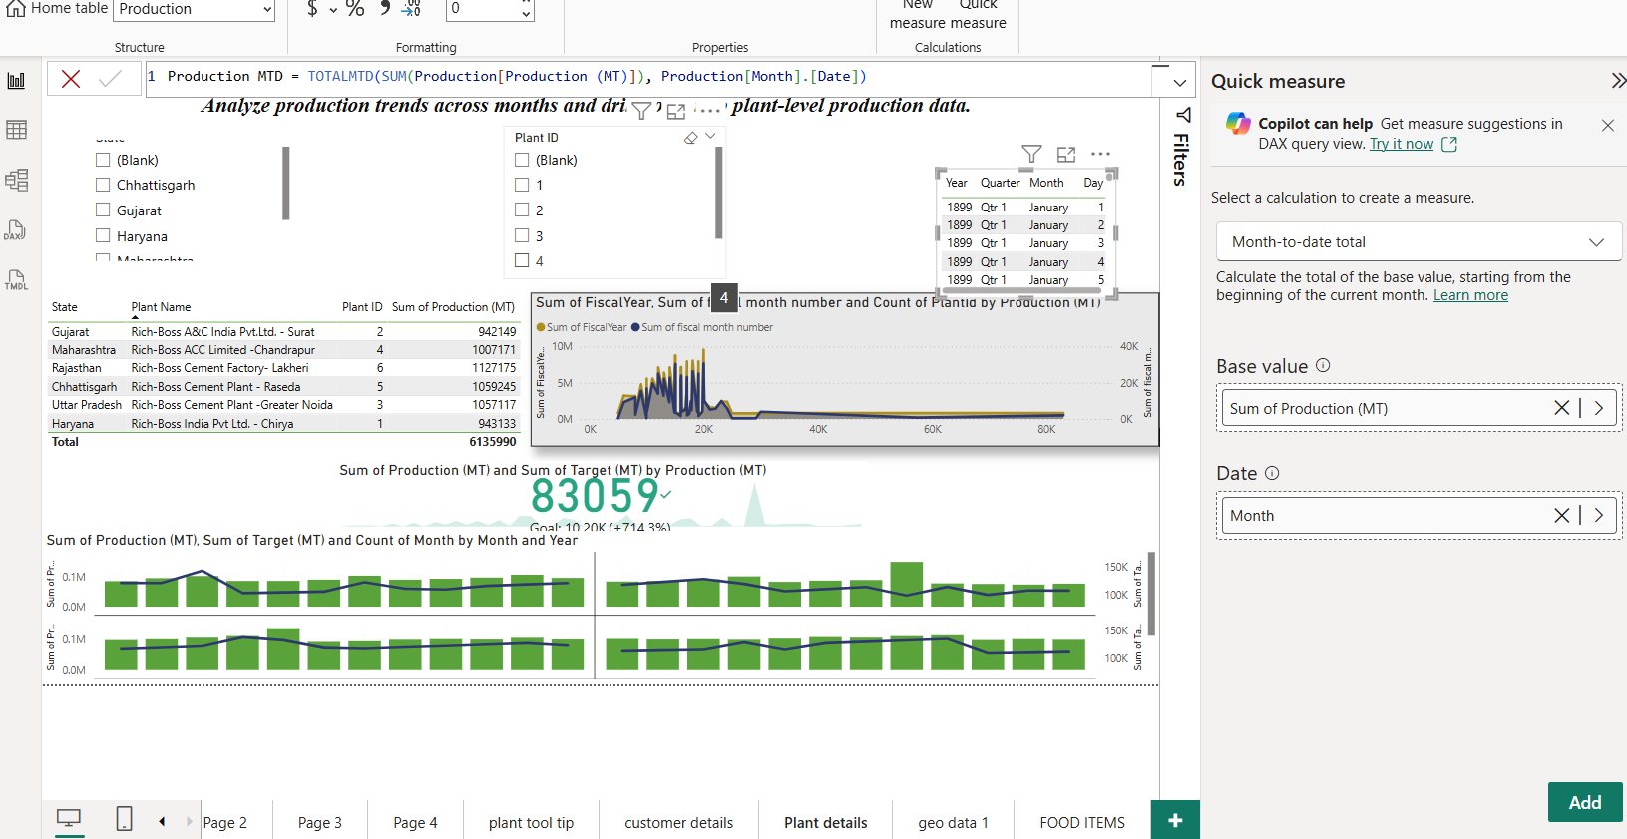

**Create a Quick Measure to Subtract Target & Production**

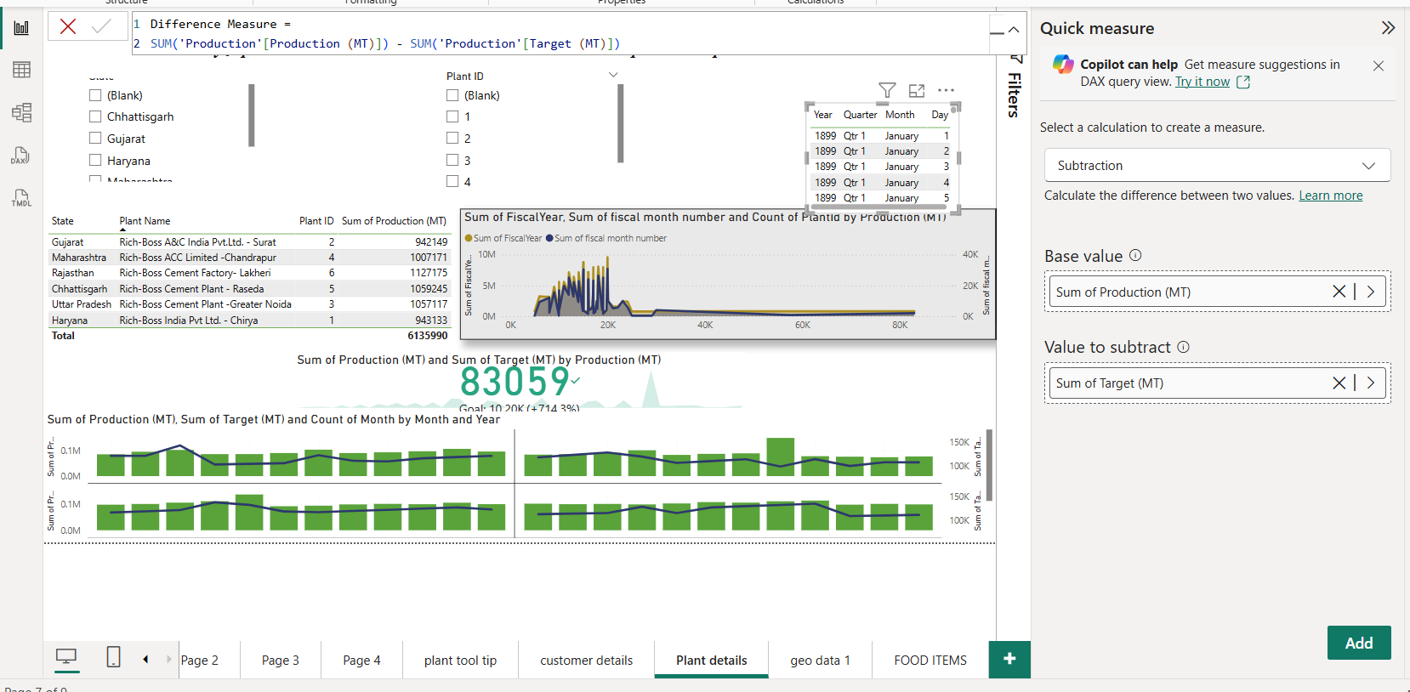

**DAY 12 – ASSIGNMENT**

**Add a “0” at the End of Every Response ID**



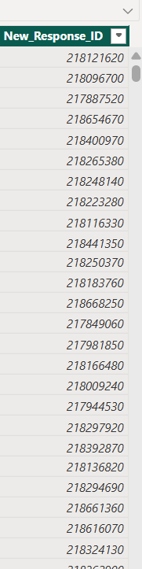

**Convert Age Column to Two Decimal Places**

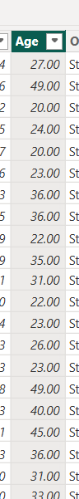

**Apply Negative Sign to All Order IDs**



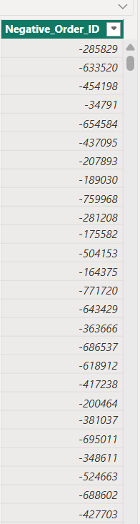

**DAY 13 – ASSIGNMENT**

**1. Create a Measure Using CALCULATE + FILTER**

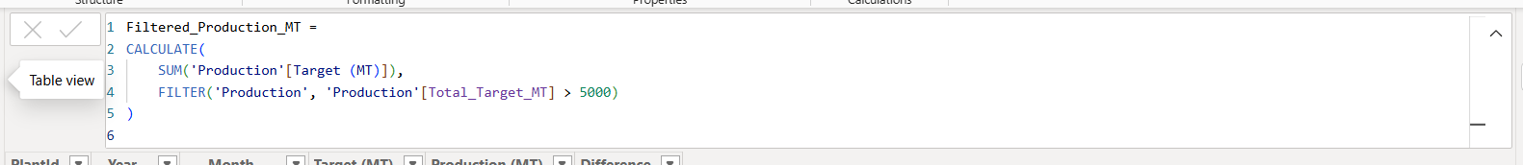

**2. Create a Calculated Column Using IF**

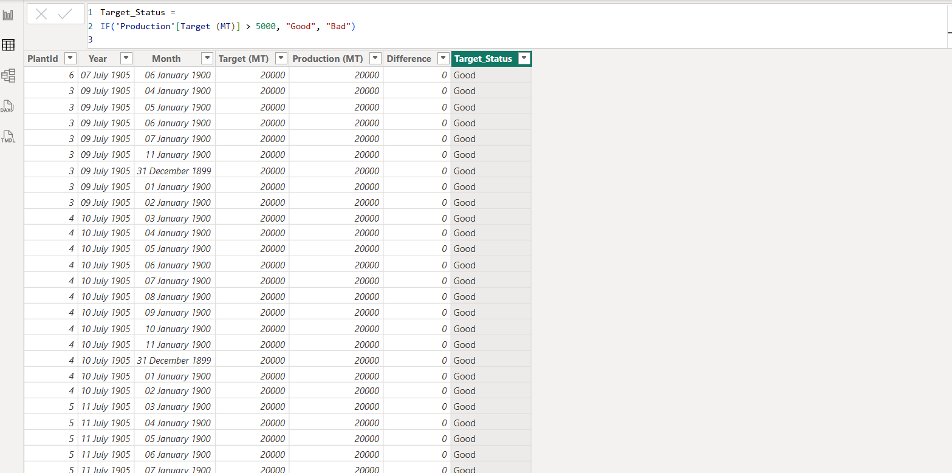

**3. Create Measures to Show Average of Production MT**

**A. Using AVERAGE function:**



**B. Using AVERAGEX function:**



**4. Create Measure for Distinct Count of Customers**



**DAY 14 – ASSIGNMENT**

